. 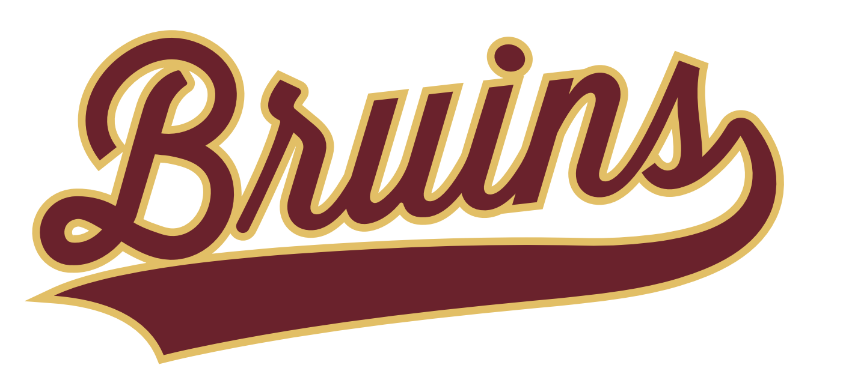
Mountain View Youth Sports Equipment Checkout Agreement
Player Name: _________________________________ Grade: ________
Parent/Guardian Name: ______________________________________________________
Parent/Guardian Phone Number: _____________________________________________
Helmet #: _______________________ Shoulder Pad #: ____________________

Deposit: A $150.00 deposit check, payable to Mountain View Youth Sports, is required upon equipment checkout. The check will be held and not cashed unless the issued equipment is not returned by November 15, 2025, or is returned in damaged condition beyond normal wear and tear. If equipment is returned in good condition by the deadline, the deposit check will be returned or destroyed.
Terms and Conditions:
- Equipment Responsibility: I understand that I am responsible for ensuring the return of all equipment issued to the above-named player by November 15, 2025. Equipment includes, but is not limited to, the helmet and shoulder pads listed above, as well as any additional items issued by Mountain View Youth Sports.
- Replacement Costs: If any equipment is lost, not returned by November 15, 2025, or returned in damaged condition (beyond normal wear and tear), I agree to pay the full replacement cost as determined by Mountain View Youth Sports. The $150.00 deposit check will be cashed to cover these costs, and I will be responsible for any additional costs if the replacement value exceeds the deposit.
- Return Process: Equipment must be returned to Mountain View Youth Sports at the designated location by November 15, 2025. Instructions for return will be provided by the organization.
By signing below, I acknowledge that I have read, understood, and agree to the terms of this Equipment Agreement. I confirm that the information provided above is accurate.

Parent/Guardian Signature: _________________________ Date: ____________________

